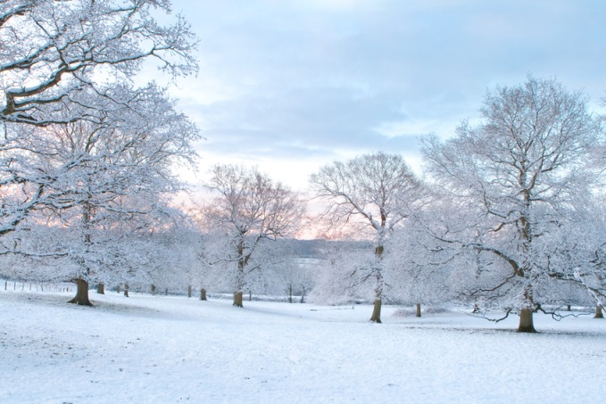

JANUARY 15, 2014 12-1:20 PM LIBRARY AUDITORIUM

- APPROVAL OF MEETING MINUTES

- PRESIDENT’S REPORT

- OLD BUSINESS
- Search Committee Update - Dean of NHES Search
- Staff Senate Council and Governance Openings
- Scheduling Grid Update

- NEW BUSINESS / ANNOUNCEMENTS
- Guest Presenters: Terrence Bennet (Liberal Learning Assessment) and John Donohue (College Seal)
- Meeting Dates for Spring 2014: Jan 15, Feb 19, March 19, April 16, May 21
- Electronic Timesheet Proposal – Carol Wells

- REPORTS

Staff Senate Councils
Elections and Constitution Council (ECC) – Matt M. (chair), Karen P.
Staff Development & Recognition Council (SDRC) – Joe O. (chair), Katy E., Dionne H., Carol W., Emily D.
Special Events & Community Building Council (SECBC) – Devon D. (chair), Tim G.,
Communications & Public Relations Council (CPRC) – Sharon S. (chair), Lynette H., Ivonne C., Carol W.
Helen Shaw Staff Excellence & Achievement Award (HSSEA) – Joe H. (chair), Deb K., Karen P., Diane M.

College Governance Committees
Committee on Academic Programs (CAP) – Jamal J., Pat VH.
Committee for Strategic Planning and Priorities (CSPP) – Nino S., Kay D.
Committee for Student and Campus Community (CSCC) – Jim S., Janice V., Carol W., Yakima M., Magda M.
Steering Committee (SC) – James D., Pat VH., Rosa Z.
Committee on Faculty Affairs – Jon. S.

Planning Councils
College Advancement (CAPC) –Kevin F., Lynette H.
Enrollment Management (EMPC) – Tammy D., Alex. L.
Facilities and Construction (FCPC) – Alexis Z., Devon D.
Finance and Budget (FBPC) – Emily L., Sean S., Ann G.
Human Resources and Staff Development (HRSDPC) –Deb K., Sharon S.
Information Technology (ITPC) – Leon D., Laurie W.

Ad Hoc Committees, Commissions, Task Forces
Search Committee for Dean of Nursing – Nino S., Grecia M.
Search Committee for Associate Provost – Monica J.
Excellence and Signature Experiences Task Force – Kevin F., Monica J., Magda M.
Board of Trustees Staff Representative Report – Lynette H, Tim G.
Middle States Decennial Self-Study – Kay D., Monica J., Jamal J., Matt M., Nino S., Rosa Z, Jon S., Pat V., Jon S.,
Campus Public Safety Advisory Council – Ginny B., Joe O., Tim G.
Campus Property Use – Seth Z.
Facilities Master Plan – Alexis Z., Devon D., Tim G., Steve S.
STEM Building Committee – Tim G., Karen P.
Presidents Climate Commitment Committee – Joe O., Rita K.
Citation Appeals – Alexis Z., Karen P., Emily D.
Dining Services Ad Hoc – Emily L.
BSC Renovation and Addition Architect Search – Seth Z. and Yakima M.

Program Councils
Advising and Student Support (ADSS) – Ivonne C., Deb K., Monica, J.
Athletics Advisory (AAPC) – Joe O., Steve S., Tim G.
Cultural and Intellectual Community (CICPC) – Diane M., Jamal J., Susan O.
Faculty-Student Collaboration (FSC) – Carol W., Mary Lynn H., Angela S.
Graduate Programs (GPC) – Jessica S.?, Nita Ball?
Healthy Campus (HC) – Libby A., Steve S., Holly H., Carol W.
Honors and Scholars (HS) – Matt M.
International Education (IE) – Kevin F., Paula R., Jon S.
Liberal Learning (LLPC) – Rita K.
Teaching and Learning – Ryan G., Diane G., Alan A., Katy E.

Curricular Councils
Teacher Education – Ginny B.

